**System Integration Comp851. Fall 2020 Project** – kp1199(Krishna)

GITHUB LINK: <https://github.com/Krishnachaitanyapureti/COMP851-Fall20>

Topic:2

I have chosen the second integration part for the project: The PTWC Widgets will be deployed and communicate their GPS position. For field operations, we would establish a database which can determine the proximity of Widgets to county and township locations. For this, we would need to deploy a GIS database to display city latitude / longitude positions.

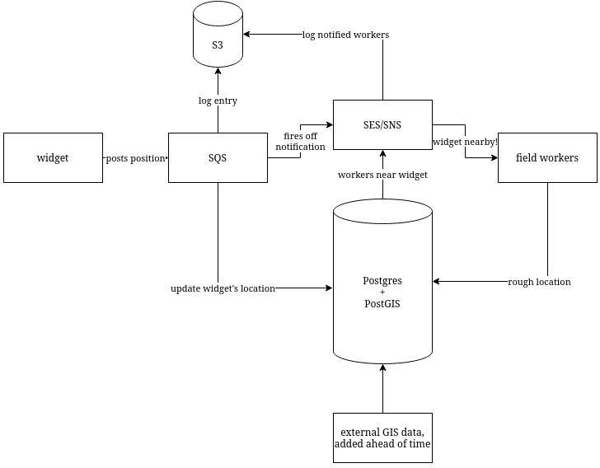Process flow

**Implementation using POSTGIS**

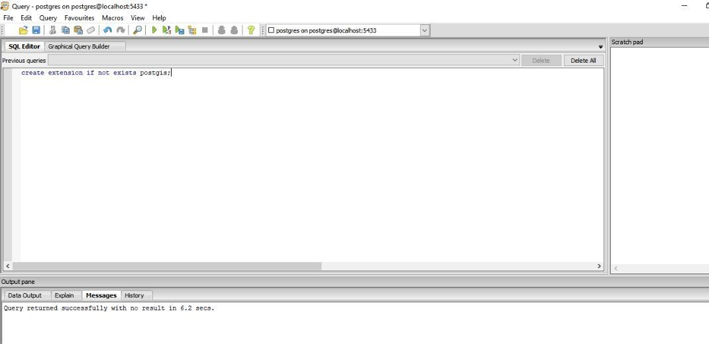**STEP1: Creating extension**

STEP 2: Creating table

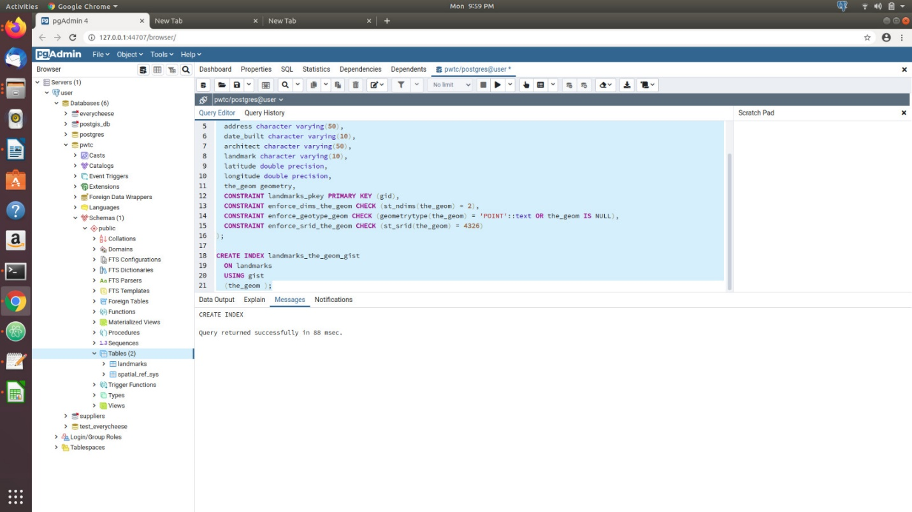

STEP 3: Importing data from CSV file

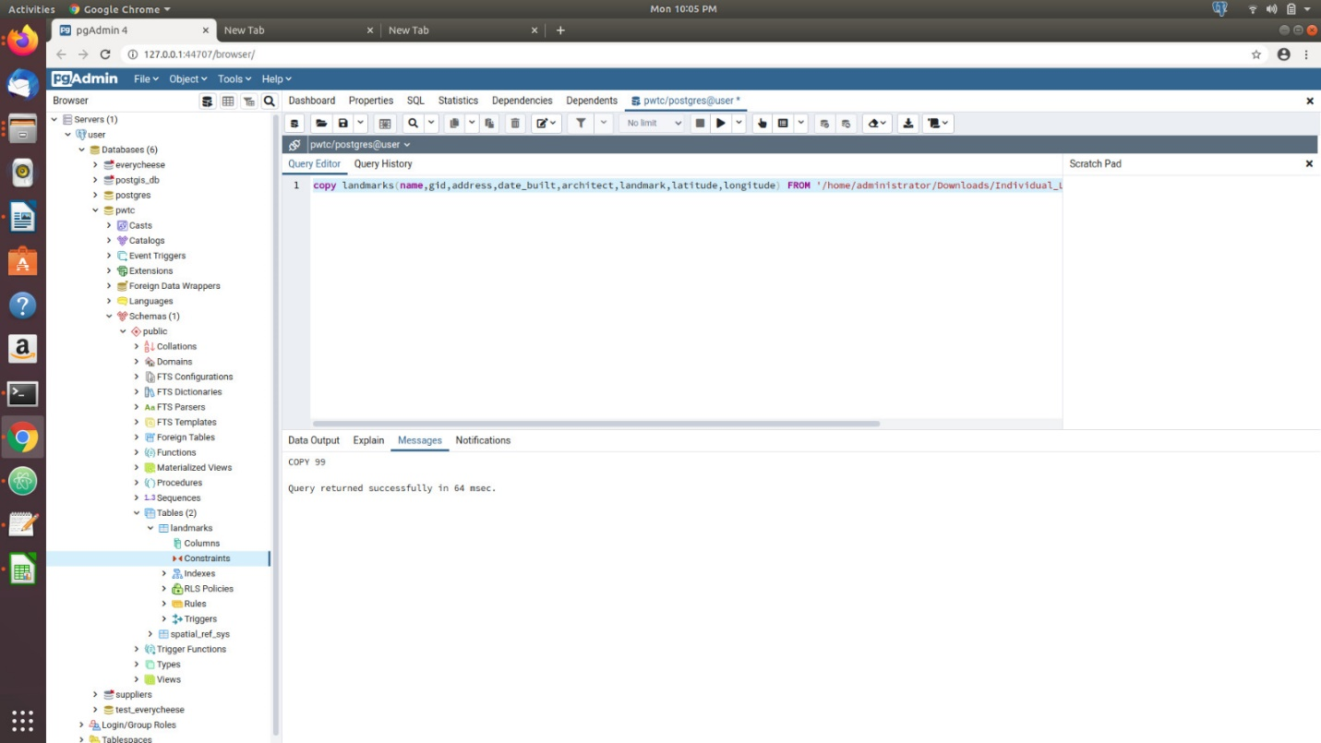

STEP 4: Displaying landmarks

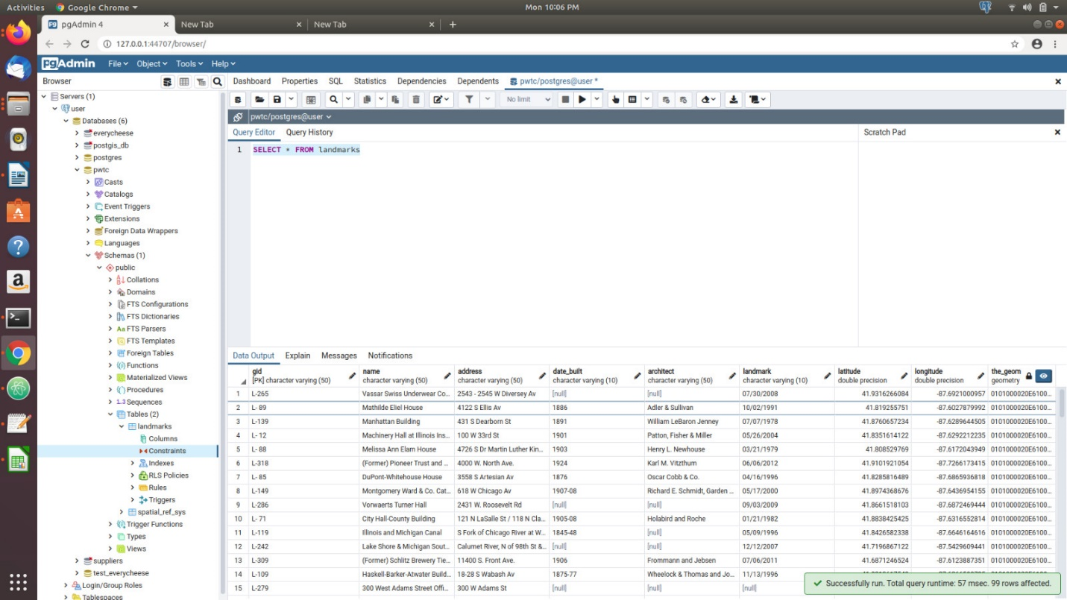

STEP 5: Convert LAT and LON readable by POSTGIS

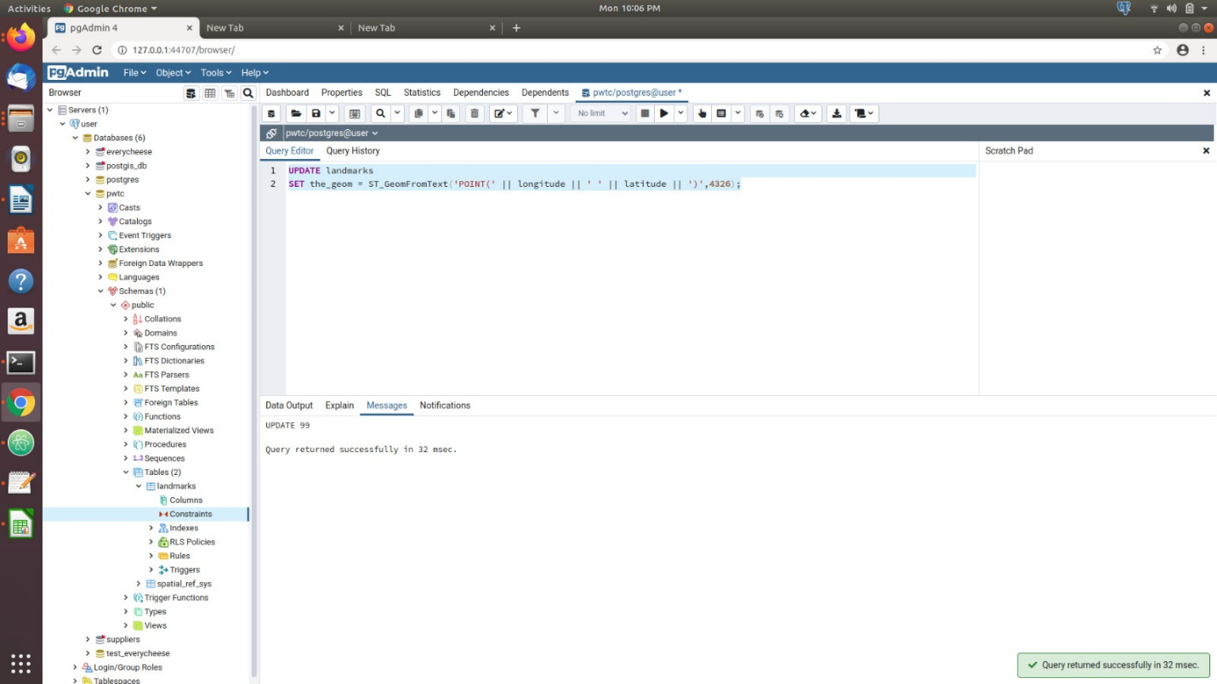

STEP 6: POSTGIS to display nearest 25 locations

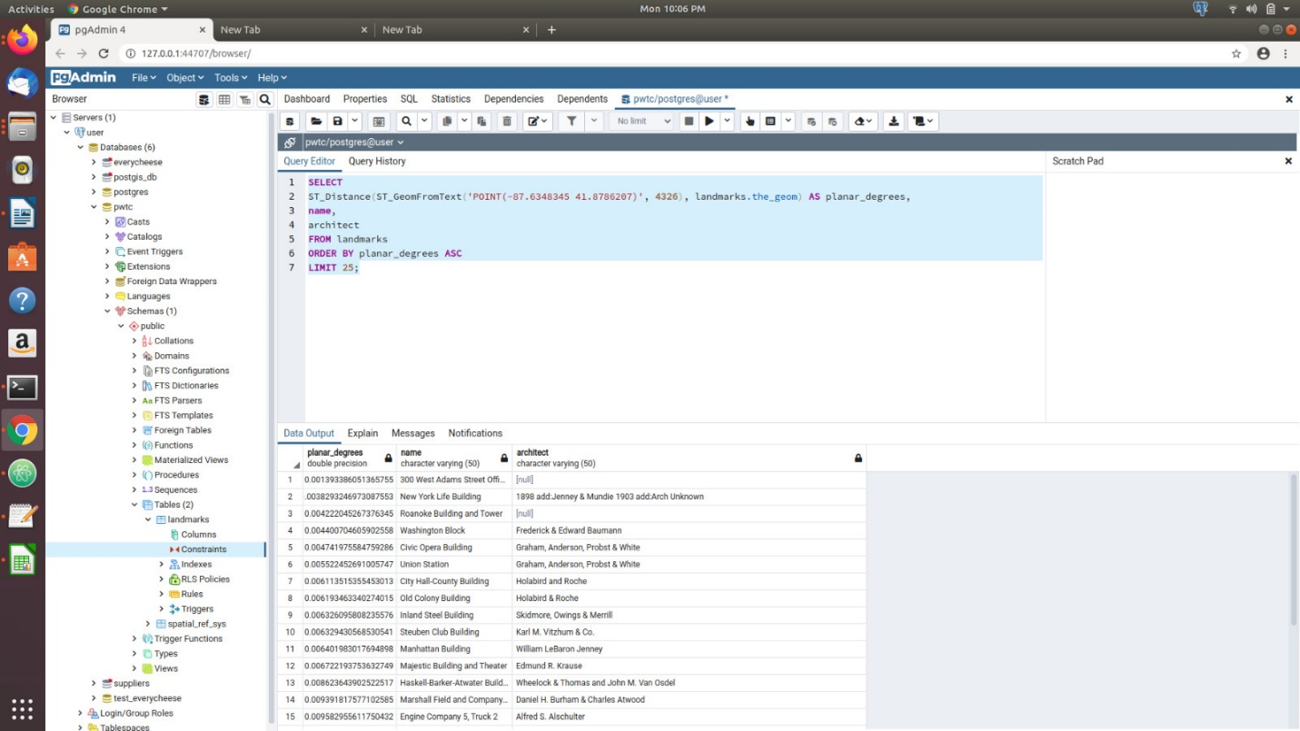

Displaying the LAT and LON in terminal using python

